Experimental Validation of Water Soluble QTY Proteins Purification

Supplementary figures

**Table 1. Characteristics of bacterial native outer membrane beta-barrel proteins and their water-soluble QTY variants.**

|  |  |  |  |  |  |
| --- | --- | --- | --- | --- | --- |
| **Name** | **RMSD** | **pI** | **MW(kDa)** | **TM variations(%)** | **Overall variations(%)** |
| BamA  [Q5F5W8](https://www.uniprot.org/uniprotkb/Q5F5W8/entry) | ___ | 9.19 | 43.36 | ___ | ___ |
| BamAQTY | 0.414Å | 9.10 | 43.81 | 27.22 (49/180) | 12.25 |
| FecA  [P13036](https://www.uniprot.org/uniprotkb/P13036/entry) | ___ | 5.47 | 73.36 | ___ | ___ |
| FecAQTY | 0.256Å | 5.47 | 73.93 | 22.6 (71/314) | 10.74 |
| OmpC  [P06996](https://www.uniprot.org/uniprotkb/P06996/entry) | ___ | 4.48 | 38.30 | ___ | ___ |
| OmpCQTY | 0.206Å | 4.48 | 38.61 | 23.75 (43/181) | 12.42 |

FecA (expressed 76kDa vs theoretical 76kDa), and BamA (expressed 65kDa vs theoretical 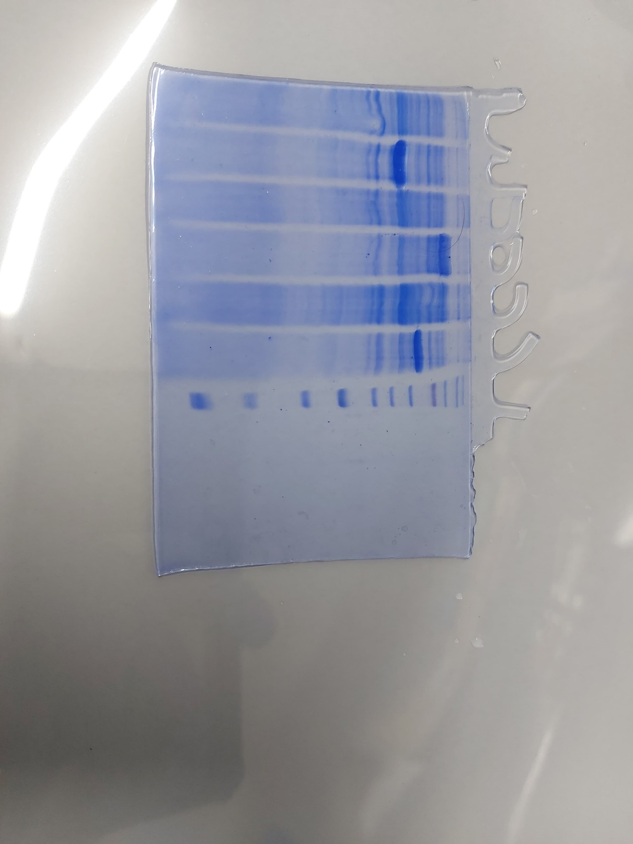52kDa) (Figure 1).

BamA

FecA

OmpC

**UI I U I I UI I L**

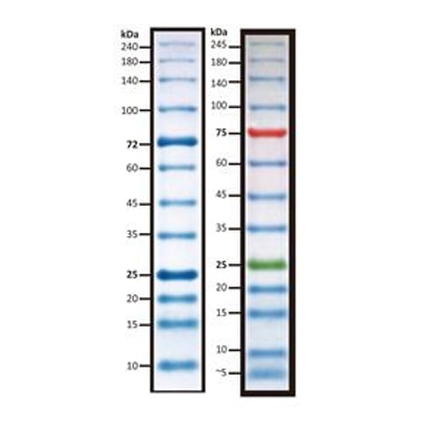

**75**

**45**

**60**

**35**

**25**

Figure1: SDS-gel for small scale expression of BamA, FecA and OmpC.UI, Un-induced sample; I-Induced sample; L- Protein Ladder

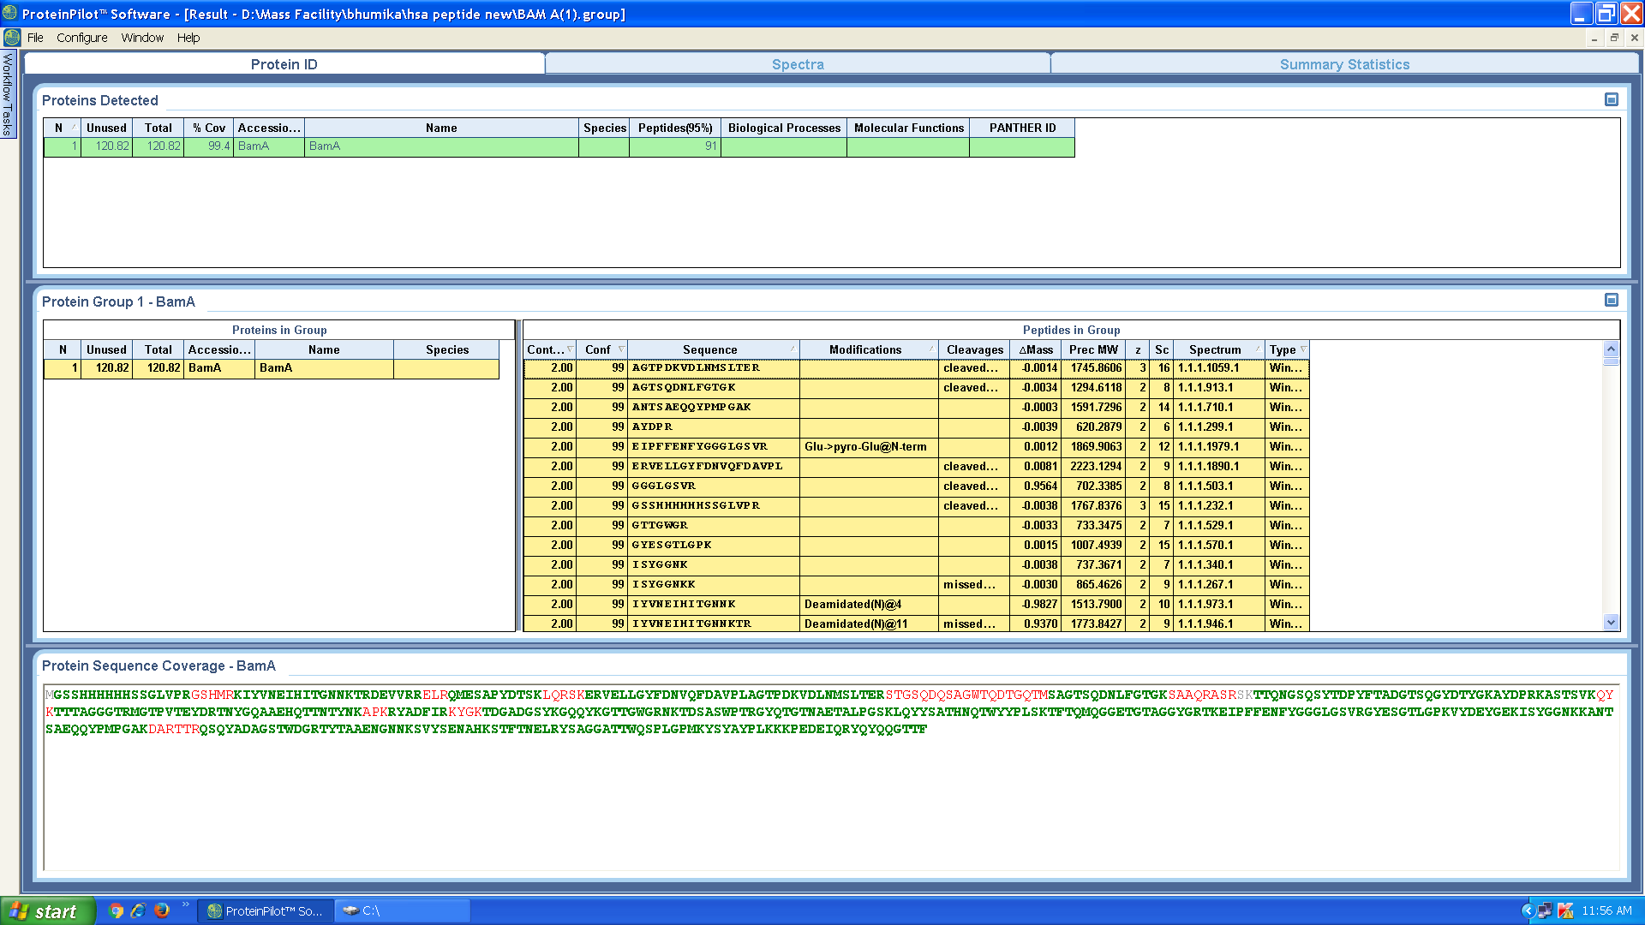**A)**

**B)**

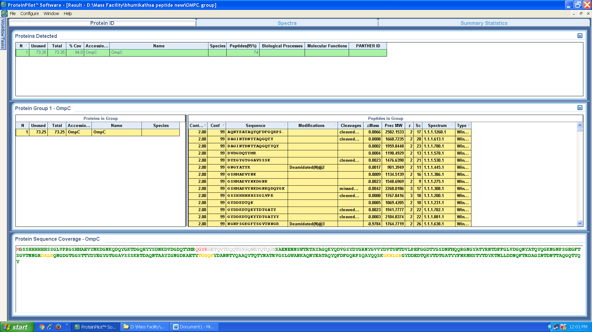

**C)**

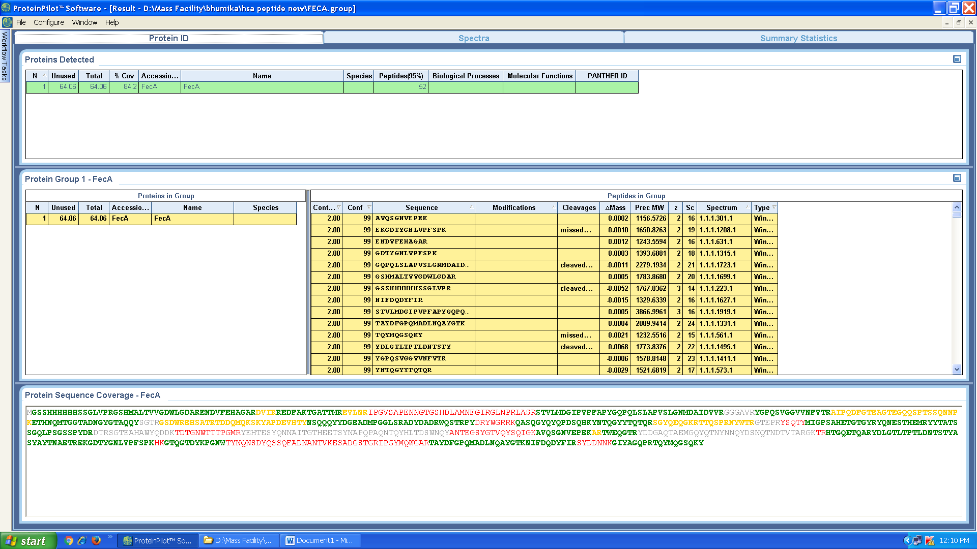

Figure 2. Mass spectrometry results confirming the expression of proteins. A) Ingel digestion mass spectrometry results for BamA protein with coverage of 90.4%. B) Ingel digestion mass spectrometry results for OmpC protein with coverage of 94%. C) Ingel digestion mass spectrometry results for FecA protein with coverage of 84%.

Confidence level indicated by colors. Green indicates the highest confidence and red the lowest.

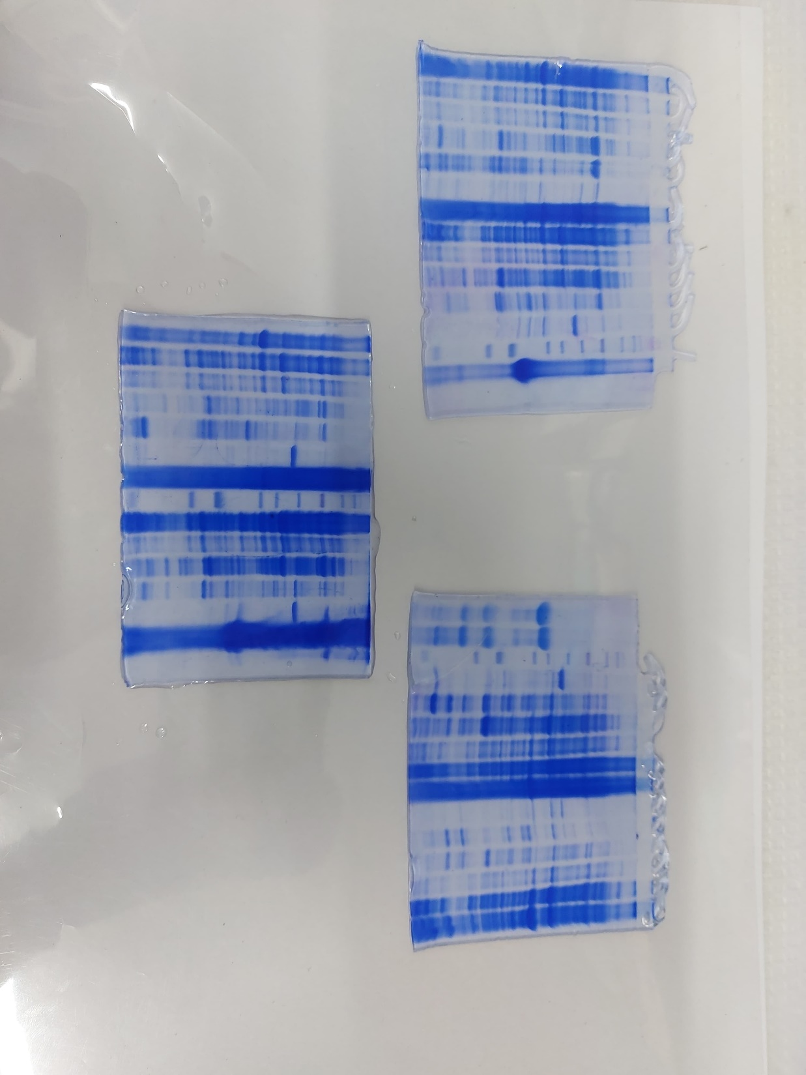

P **L** FT 0 20 200 500

P FT 0 20 200 500

75

45

**B**

**A**

FecA 16ºC

FecA 37ºC

BamA 37ºC

BamA 16ºC

P FT 0 20 200 500

P FT 0 20 200 500 **L**

75

45



OmpC 37ºC

P FT 0 20 200 500

P FT 0 20 200 500 **L**

OmpC 16ºC



75

**C**

45

Figure 3: Shows gel images of BamA, FecA, and OmpC, at two different temperatures with varying concentrations of imidazole (0mM, 20mM, 200mM, and 500mM). P= pellet, FT= Flow-through and L=ladder.

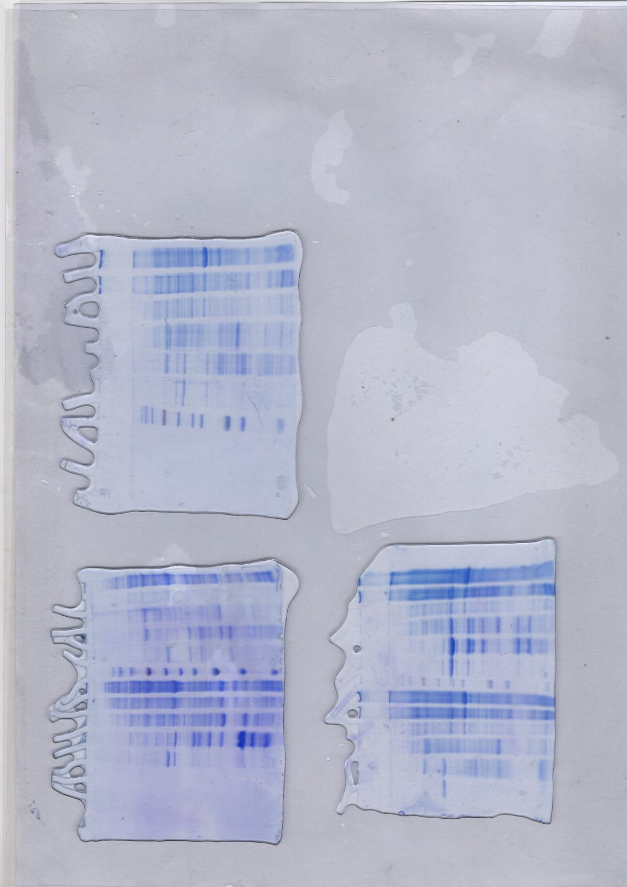

FecA

BamA

OmpC



P FT 0 20 200 500

P FT 0 20 200 500

P FT 0 20 200 500 L

L



**75**

**75**

**45**

**45**

Figure 4: Large scale protein Purification of OmpC, BamA and FecA. Protein expression seen in case of OmpC and BamA. P= pellet, FT= Flow-through and L=ladder.

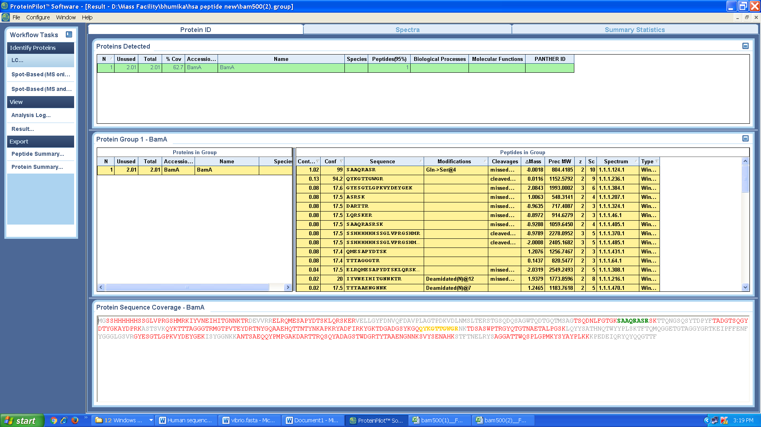**A)**

**B)**

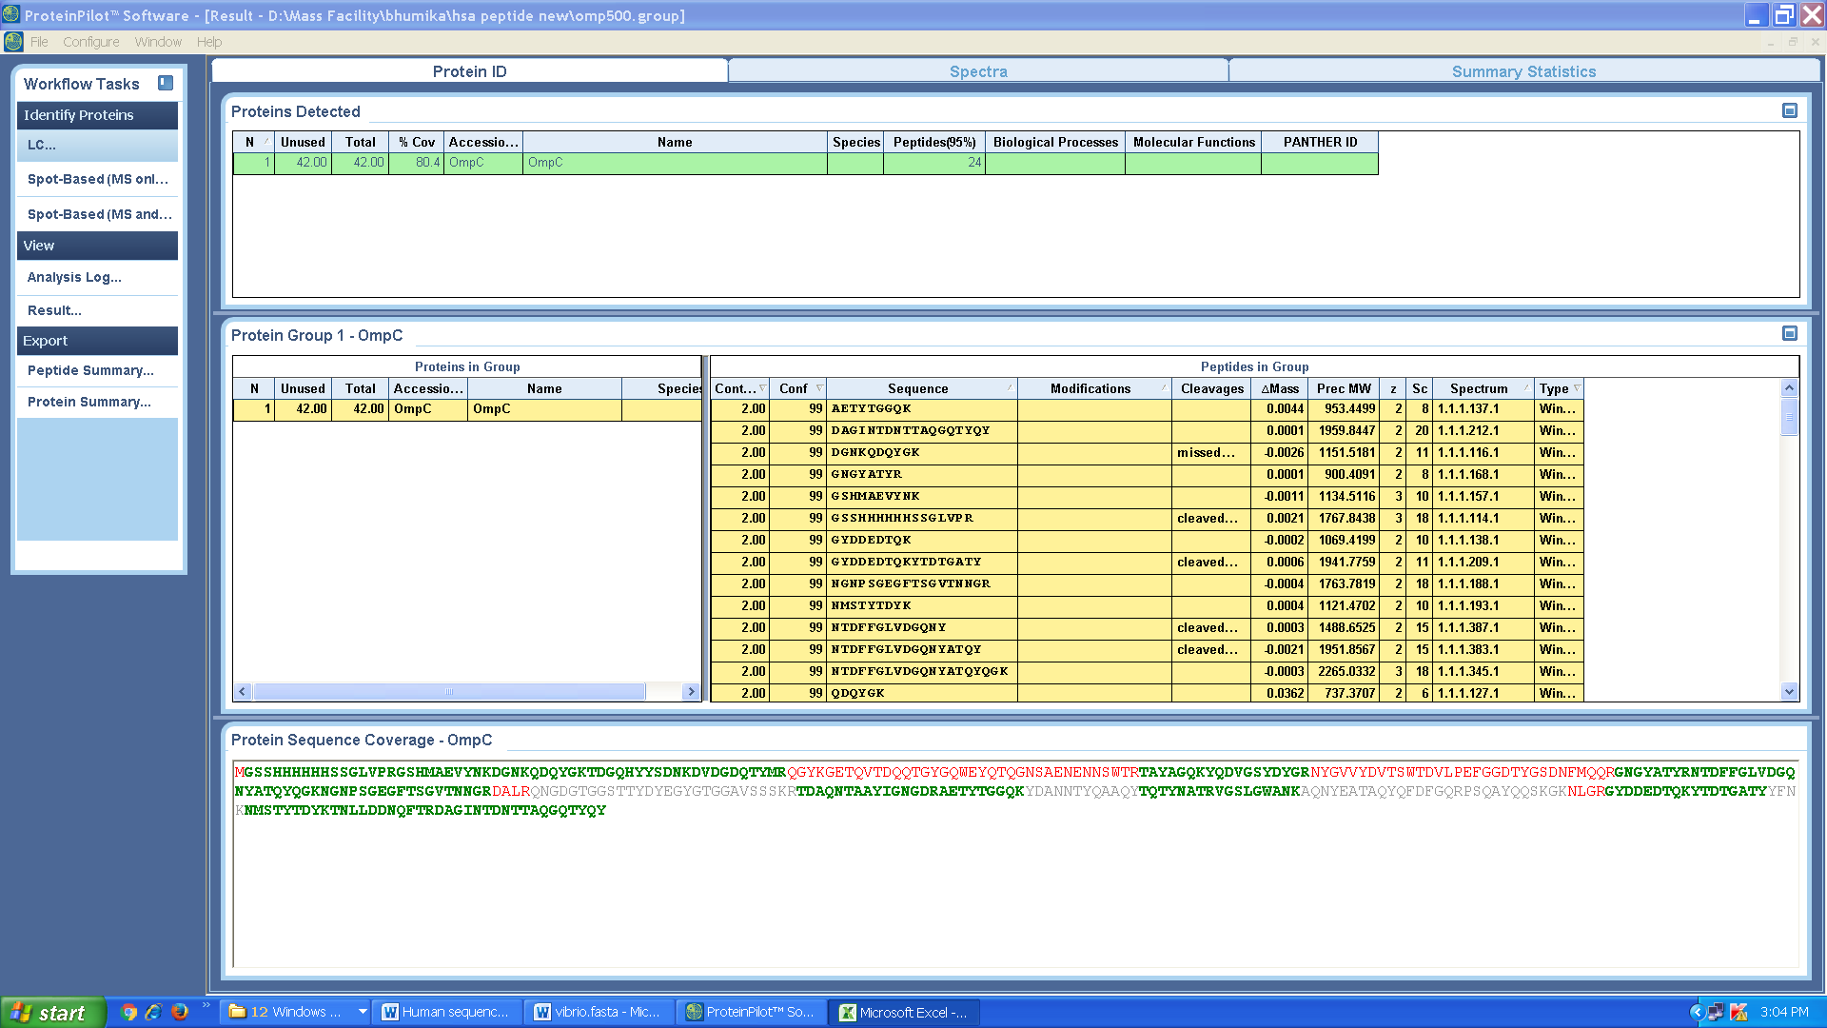

Figure 5: Illustrates comprehensive mass spectrometry data. A) Ingel results for BamA B) Ingel results for OmpC.



OmpC

BamA

FT 0 20 200 500 L FT 0 20 200 500

**75**

**45**

Figure 6: Protein purification of BamA and OmpC. FT= Flow-through and L=ladder